https://personal-sites.deakin.edu.au/~s224212855/sit774/index.html

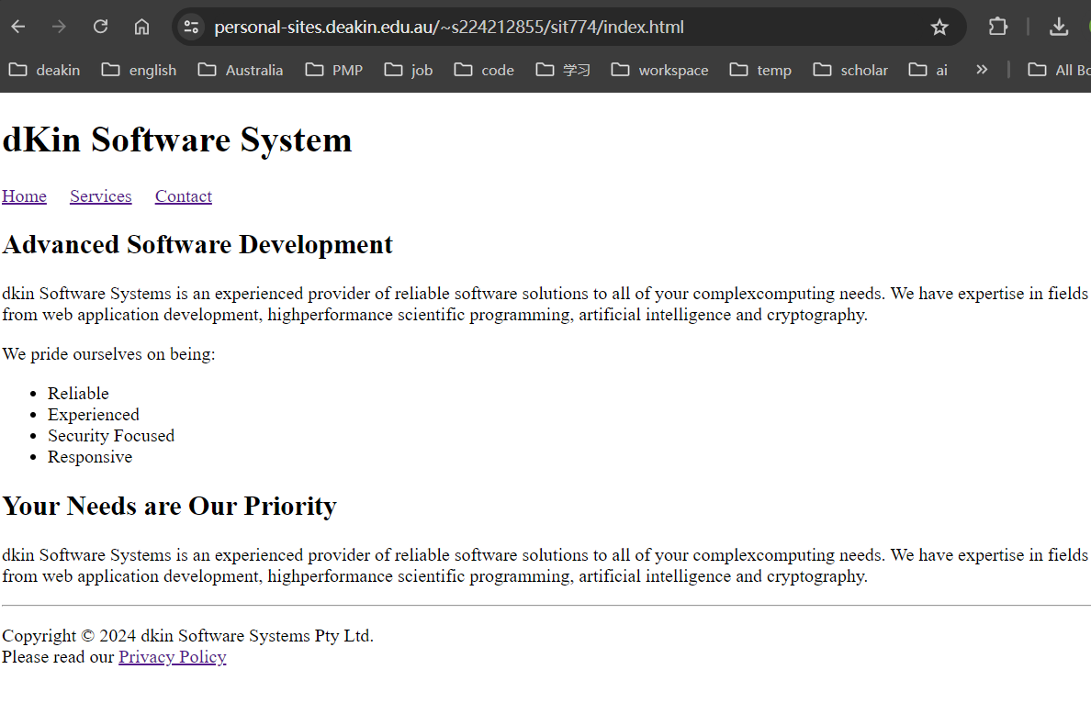

Local access

